**EFS**

1. **What is AWS Elastic File System?**
2. **When to use AWS Elastic File System?**
3. **Benefits of using AWS EFS.**
4. **Demo: Create and use EFS.**

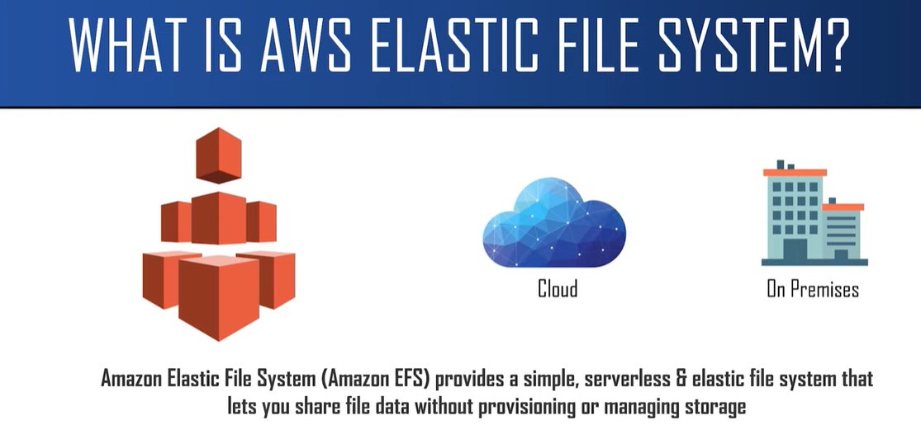

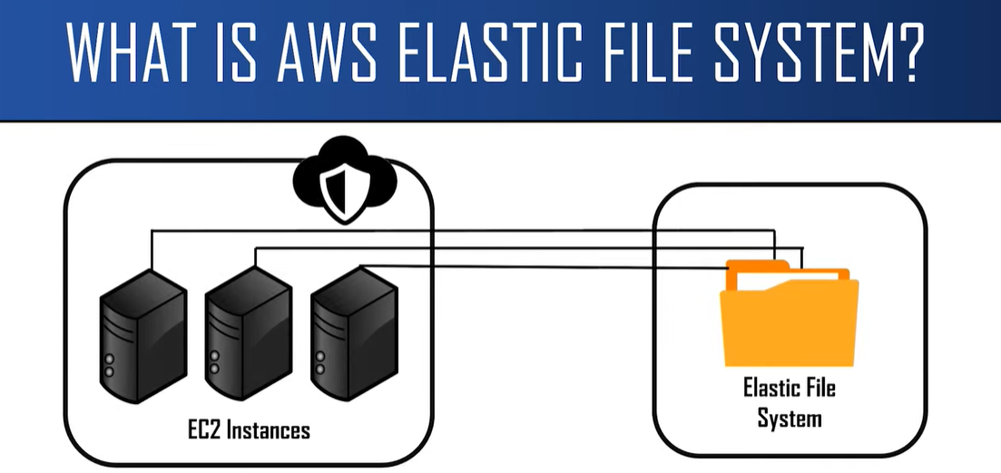

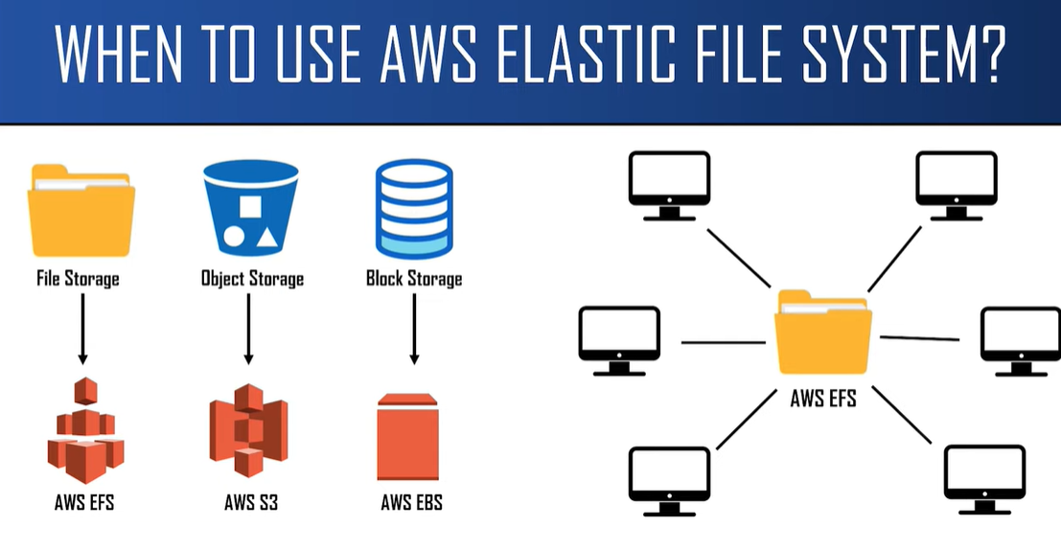

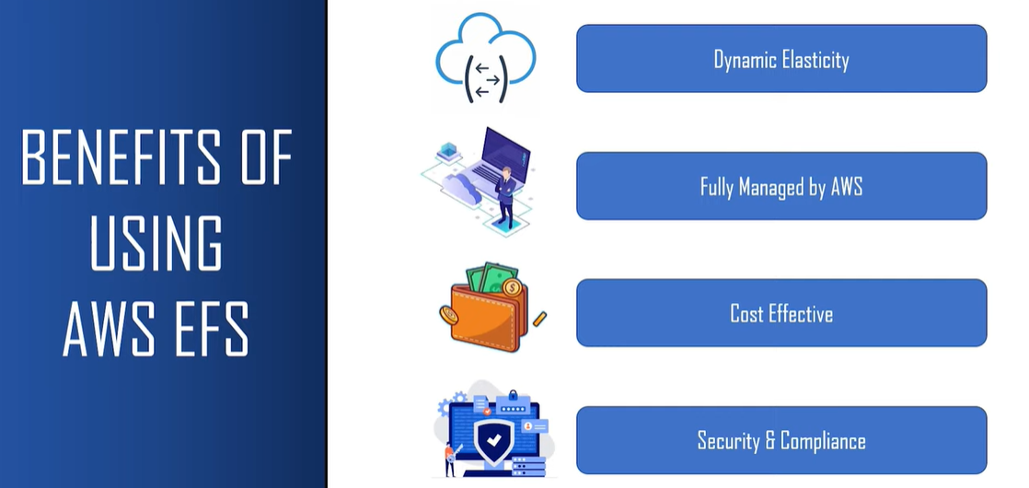

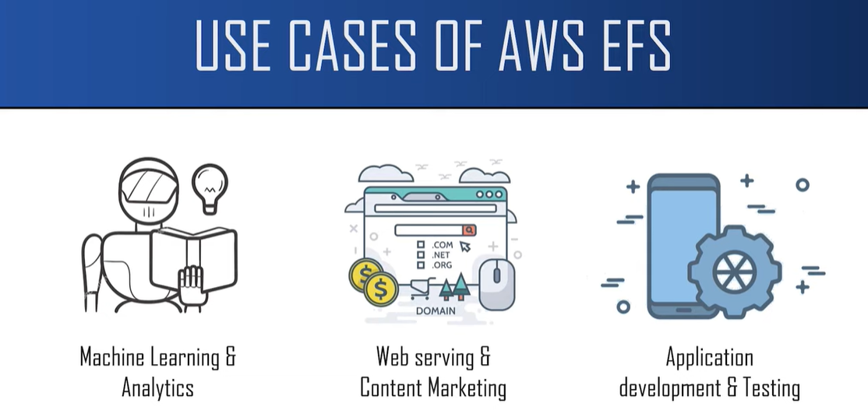

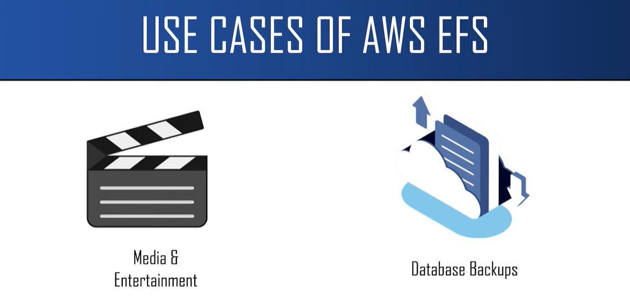

**We Need To create a Linux Instance because EFS does not supports Windows Operating system. (This will be one of the drawback of EFS).**

**First, we need to create a security group:**

**Steps:**

1. **Let us create our own security group by clicking on “Create security group”.**

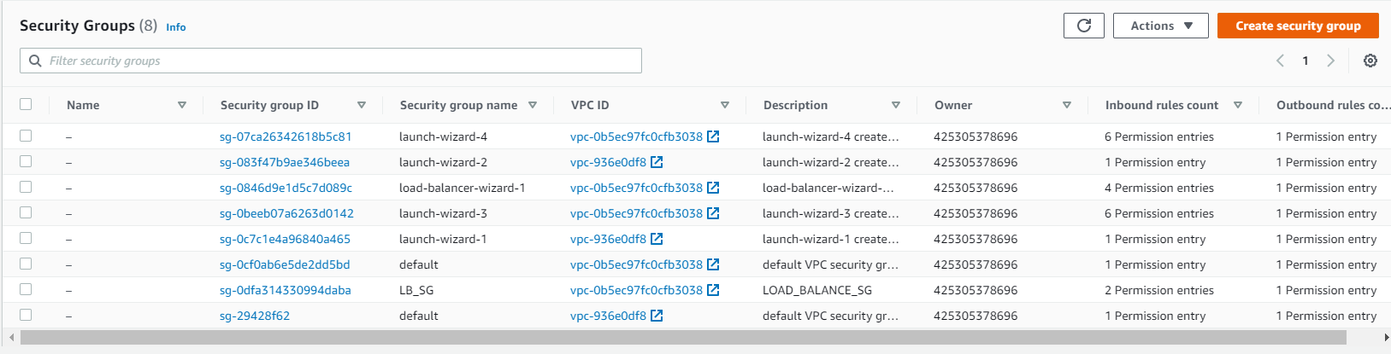

1. **For this demo we are going to create two security groups, one for the instance and other for the file system.**
2. **Creating a first security group for a EC instance.**

**EC2-SSH – which will allow us to connect from EC instances to EFS file system.**

**Then we set the inbound rule.**

**Inbound rule means what are all the traffic we allow in , in our case we use only SSH.**

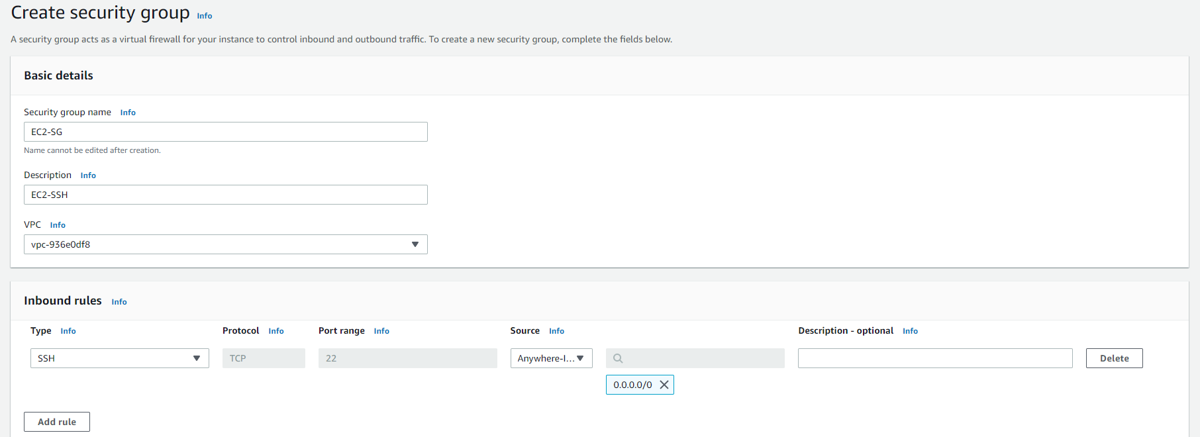

1. **Create another security group for the EFS file system.**

**Name it EFS Security group, in description TCP Traffic, inbound rule TCP and source will be from anywhere.**

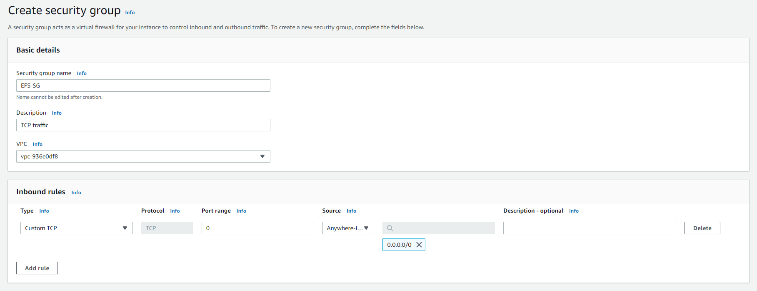

1. **Now we are going to create a file system.**

**Open EFS service and click of the “create file system” and start creating the file system.**

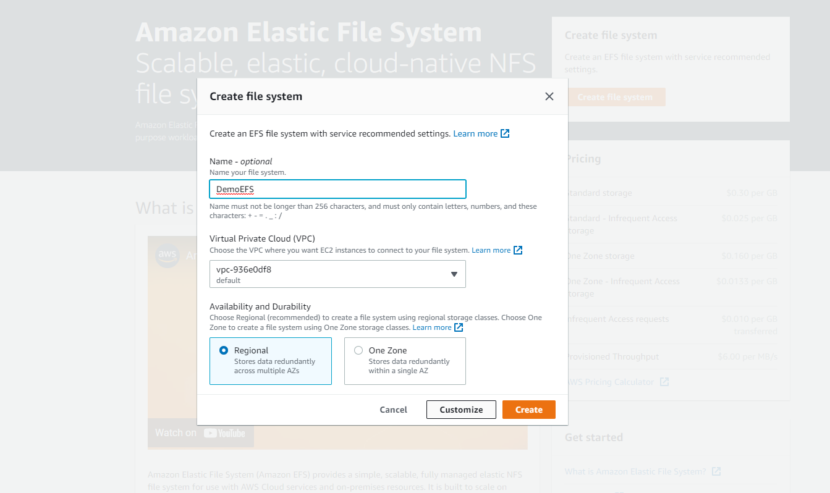

**Give a name, choose default VPC and click customize.**

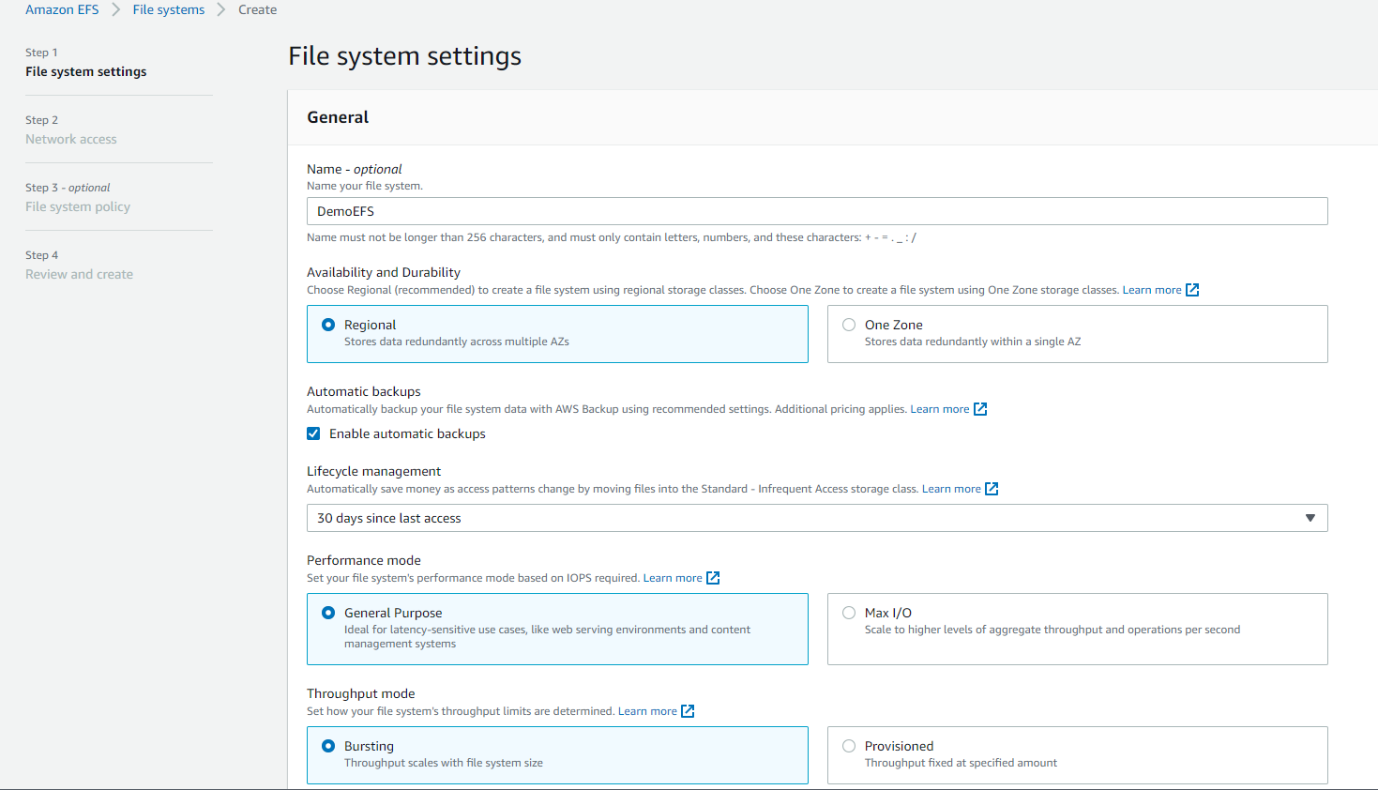

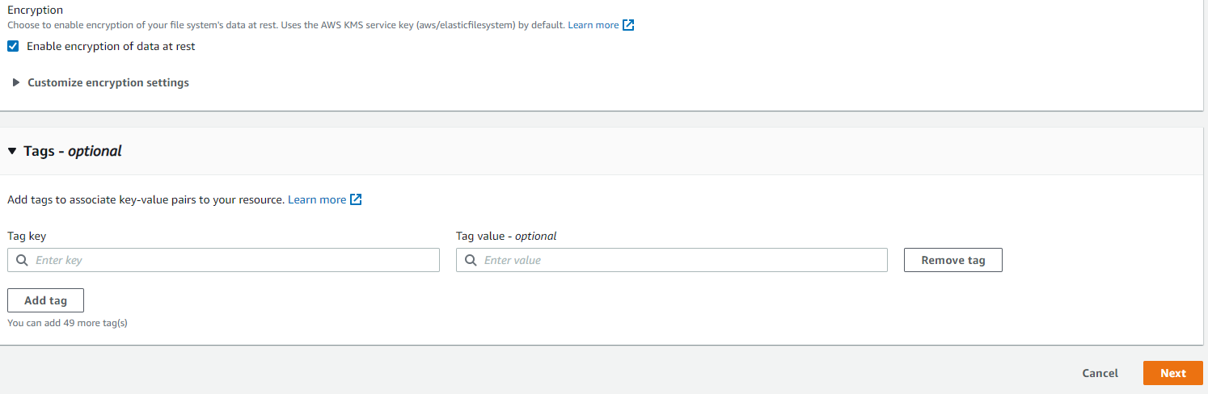

**Click on Next.**

**Network Access:**

**Remove all the default security groups and set our security group.**

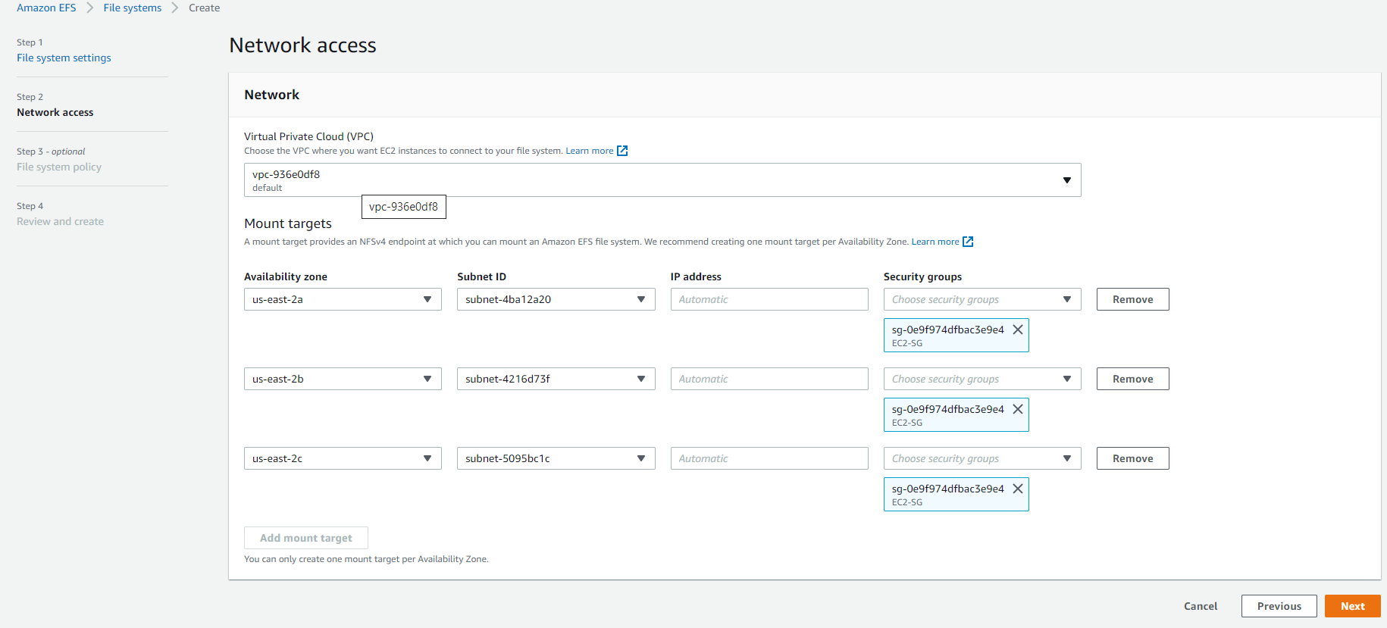

**Click on Next.**

**File system Policy:**

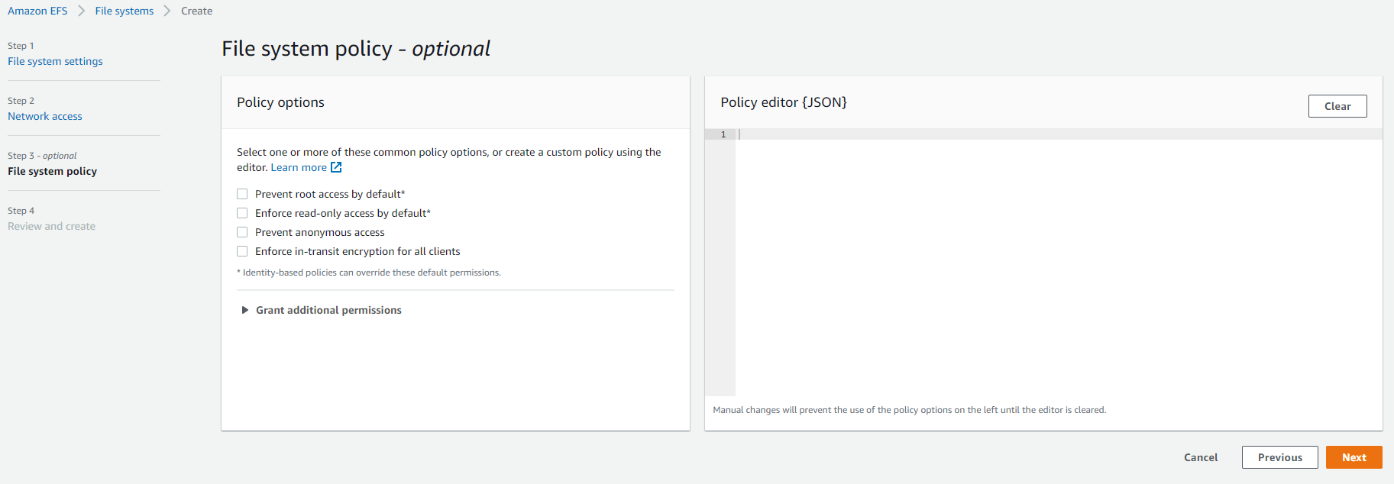

**Click on Next**

**Review and Create:**

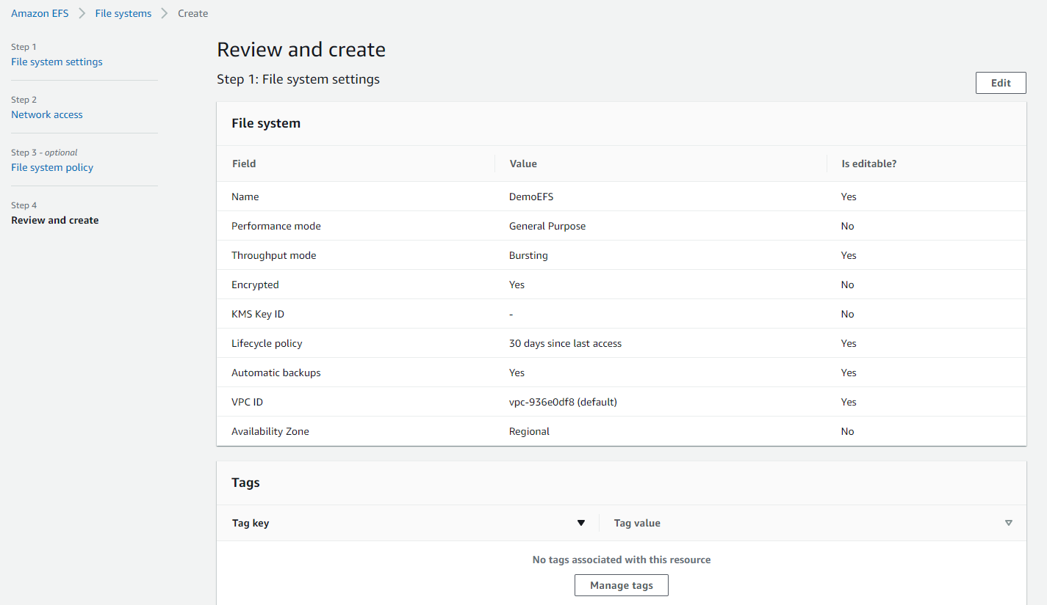

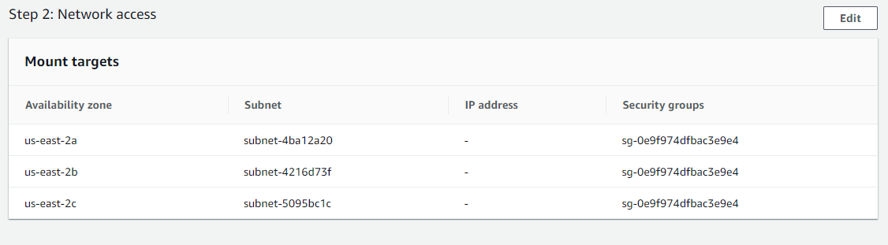

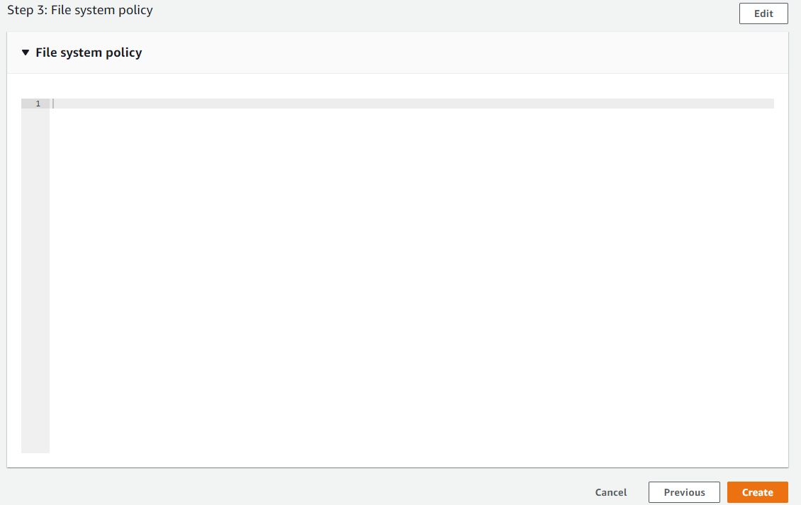

**Click on Create.**

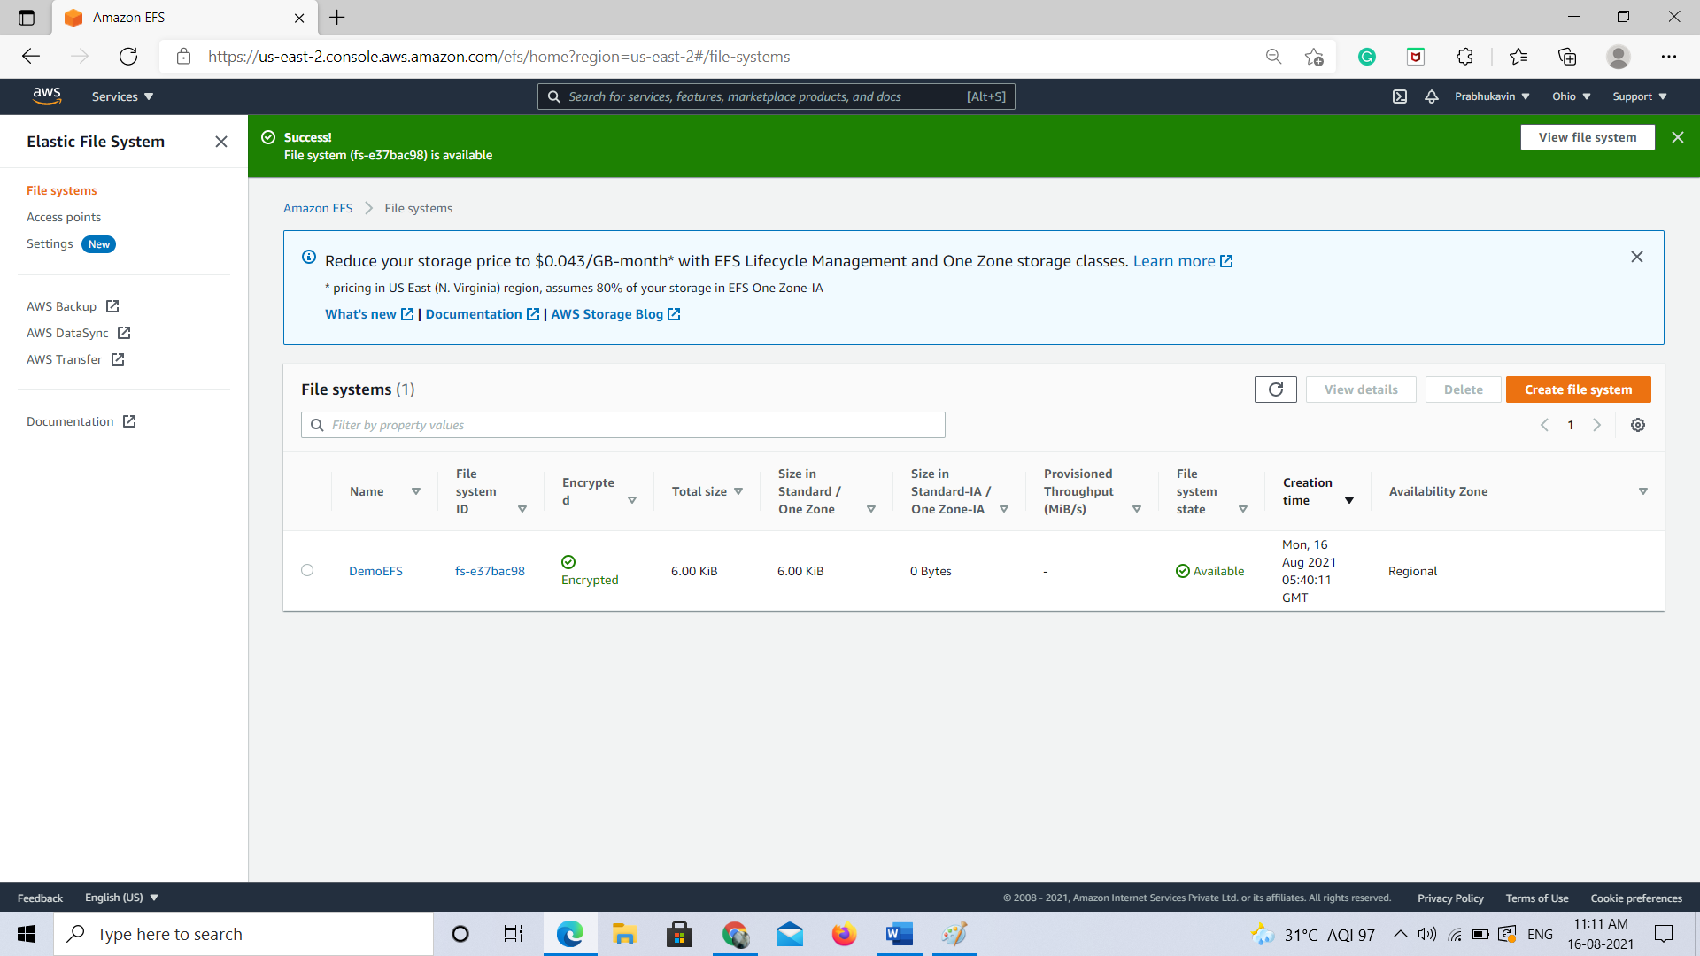

**Create a new EC2 Instance.**

**Click on launch instance.**

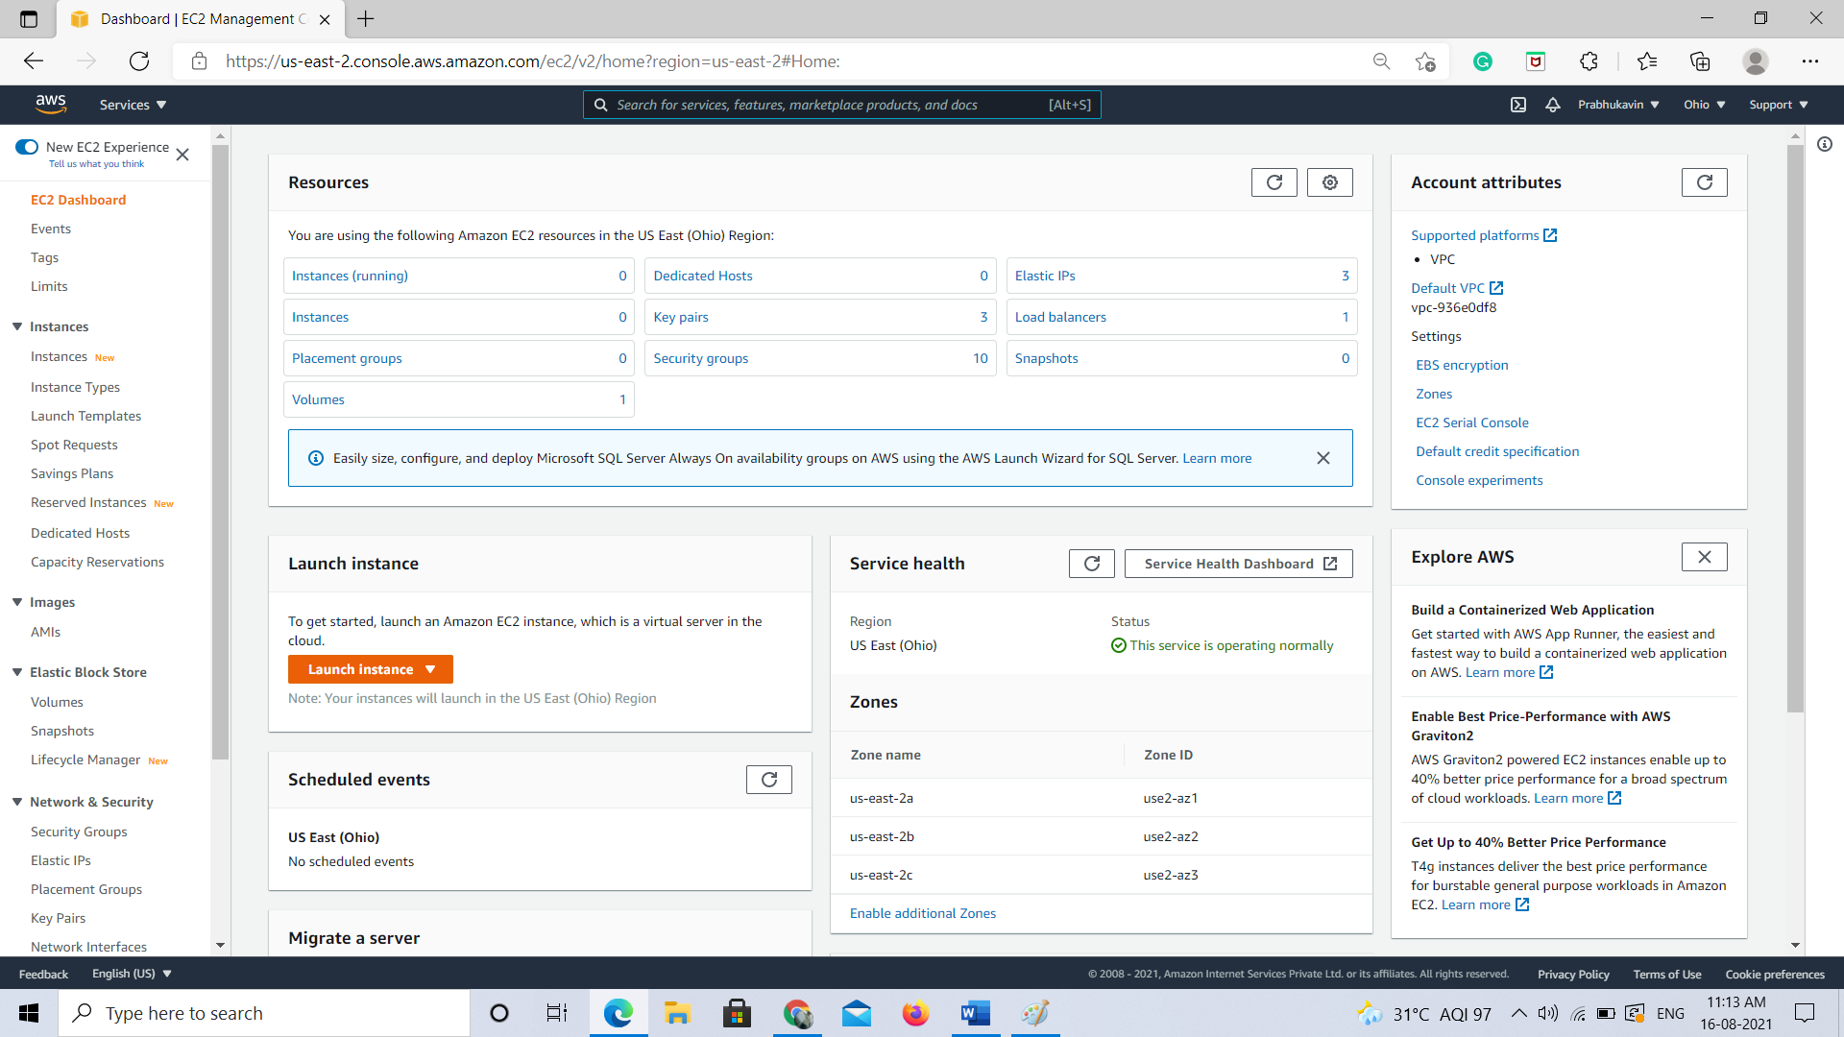

**Select Amazon Linux 2 AMI.**

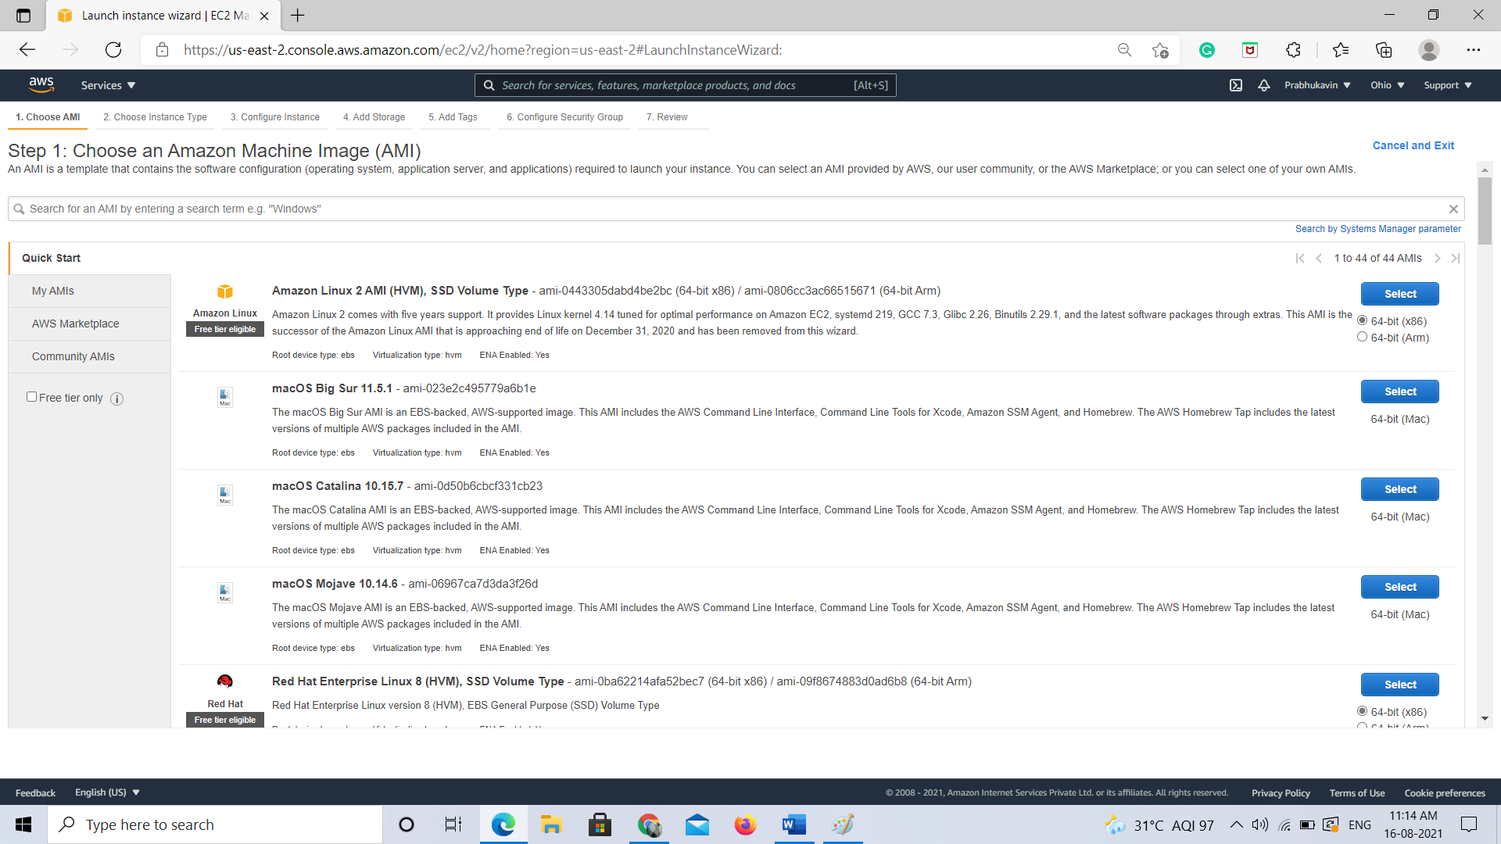

**Choose an Instance type.**

**Choose review and launch.**

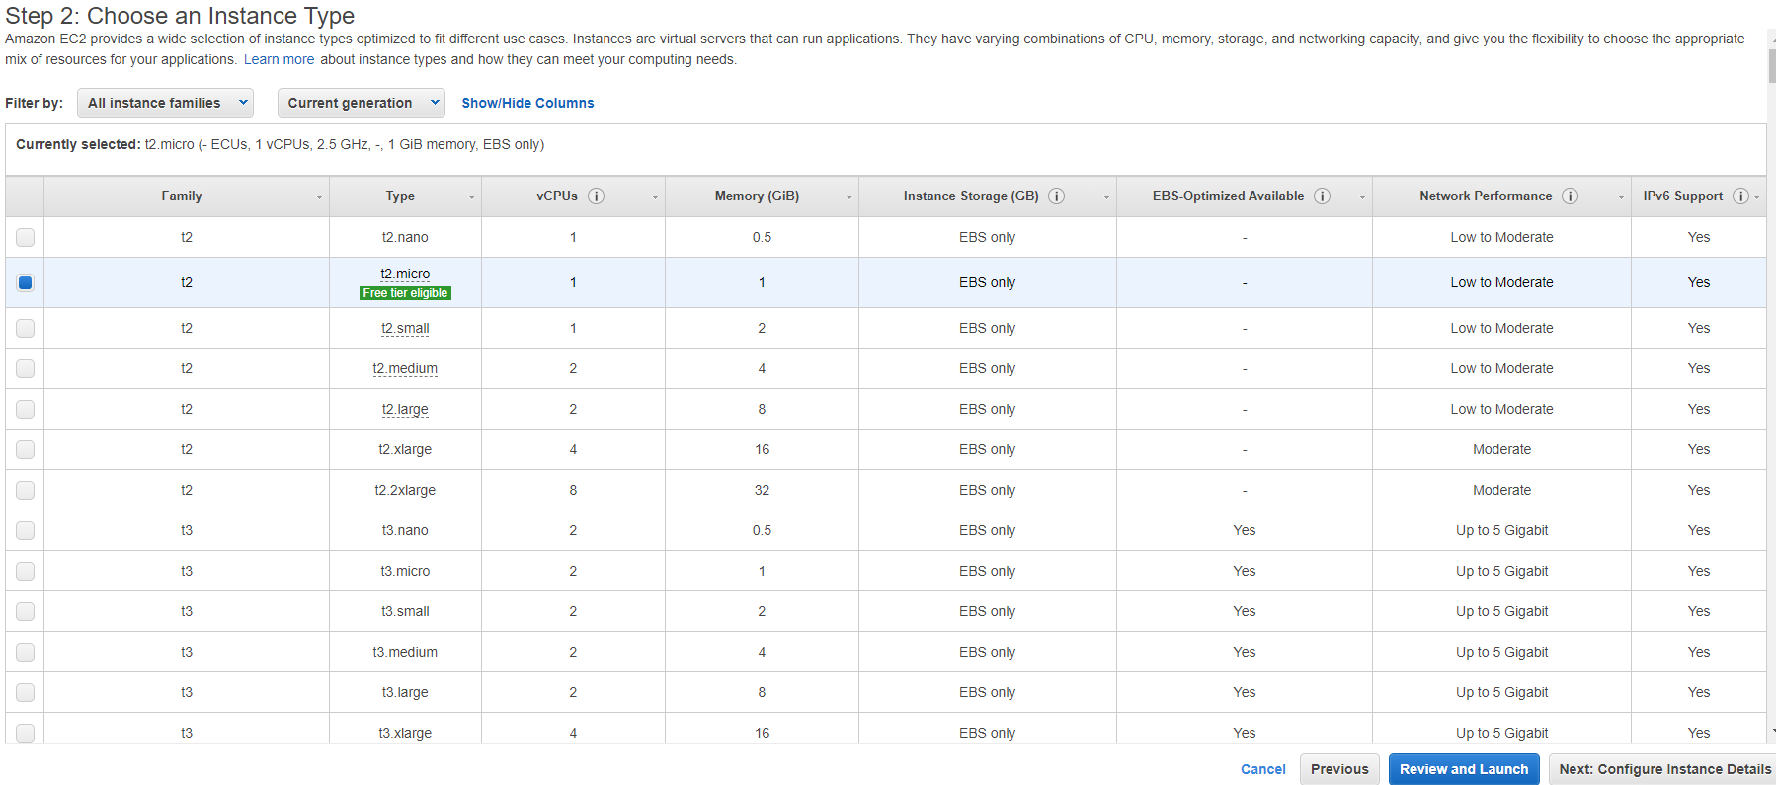

**Click of configure Instance and ad our file system.**

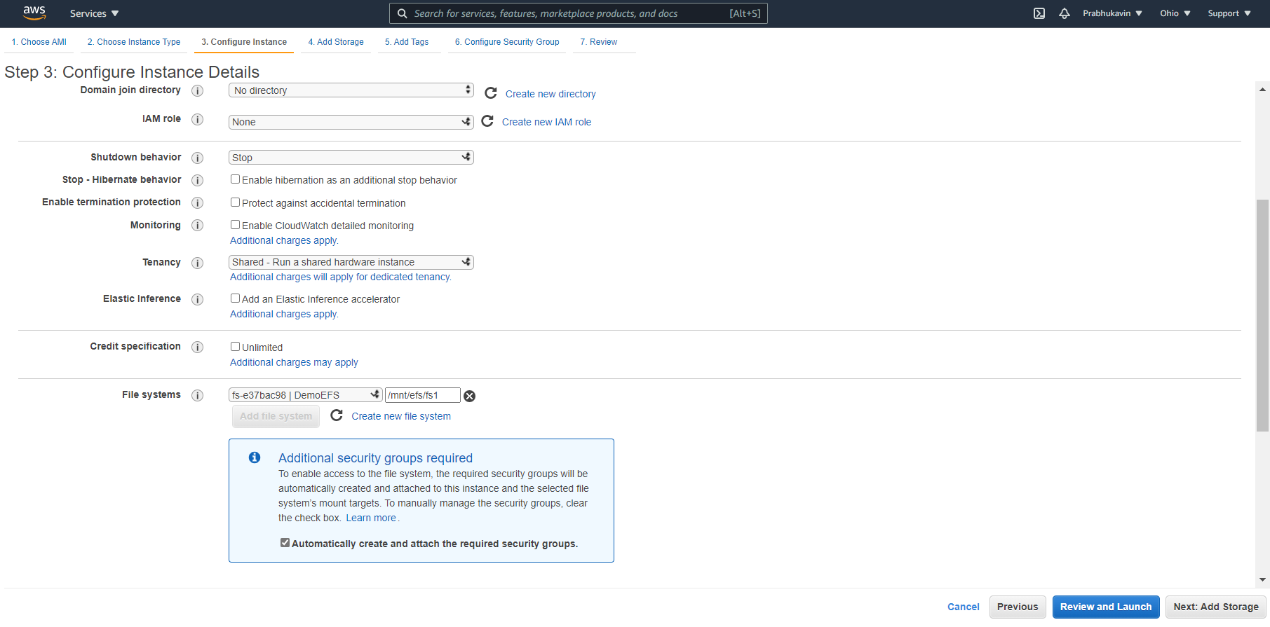

**After adding file system go to configure security group where we will add a security group.**

**Select an existing security group – EC2-SG.**

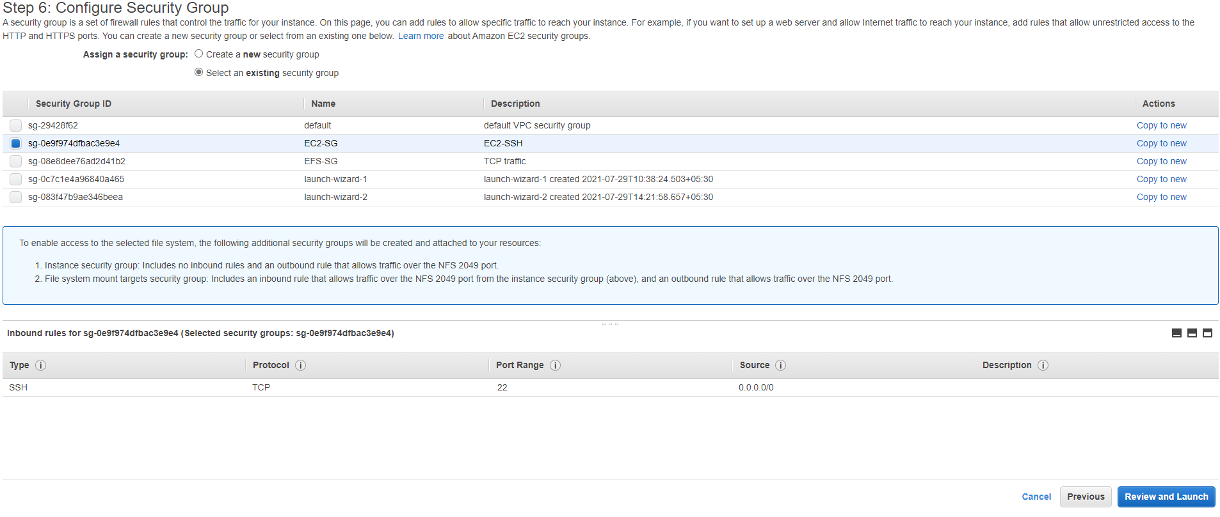

**Click on Review and launch.**

**Launch the instance by clicking the “launch”.**

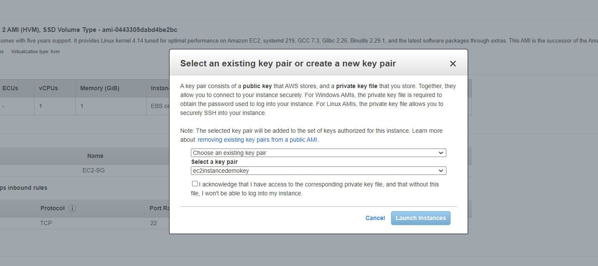

**Choose an existing keypair and click “launch Instance”.**

**Click on the instance id of the created EC2 Instance.**

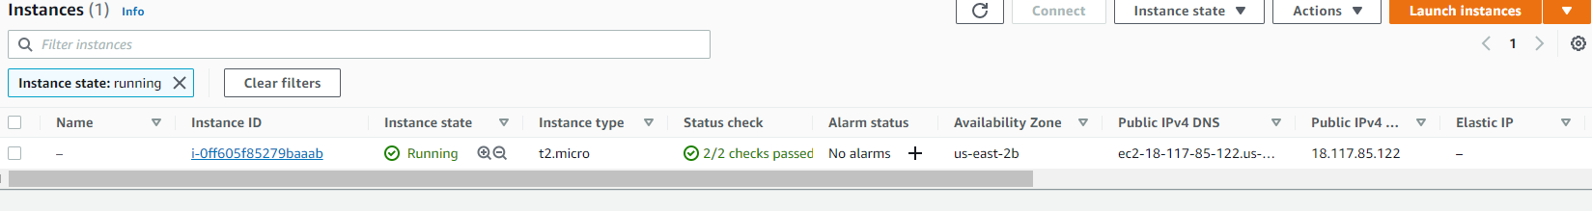

**Click connect button.**

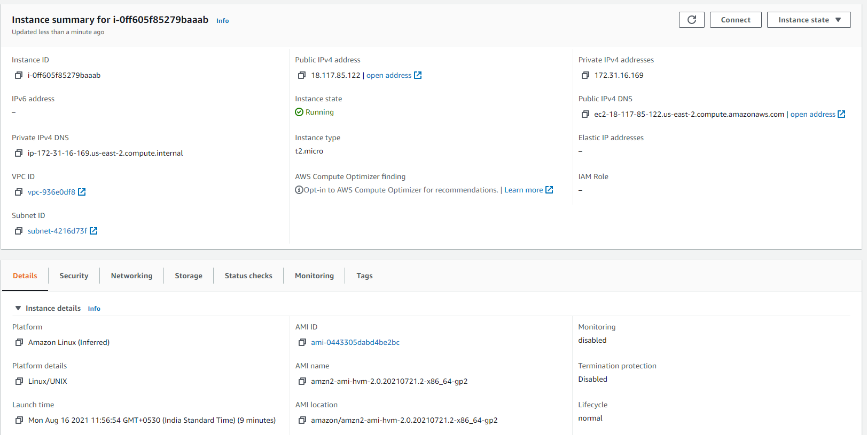

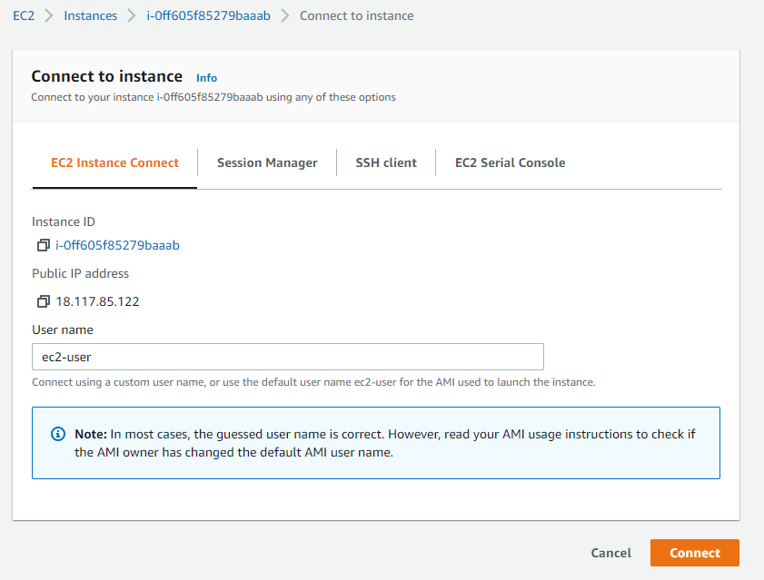

**Click on connect**

**Amazon Linux 2 AMI is up and its working**

**Type : df -T -h**

**If we click on this command our EC2 is mounted on the EFS**

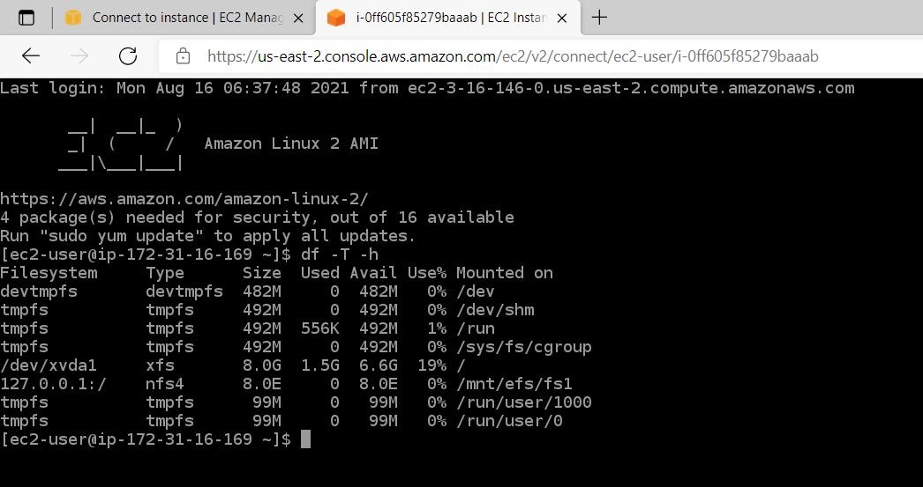

**After this delete the EFS and terminate the EC2 Instances.**